**AI-Based Diabetes Prediction System**

* Phase 5
* Documenting the design thinking process and preprocessing, visualization and innovative techniques

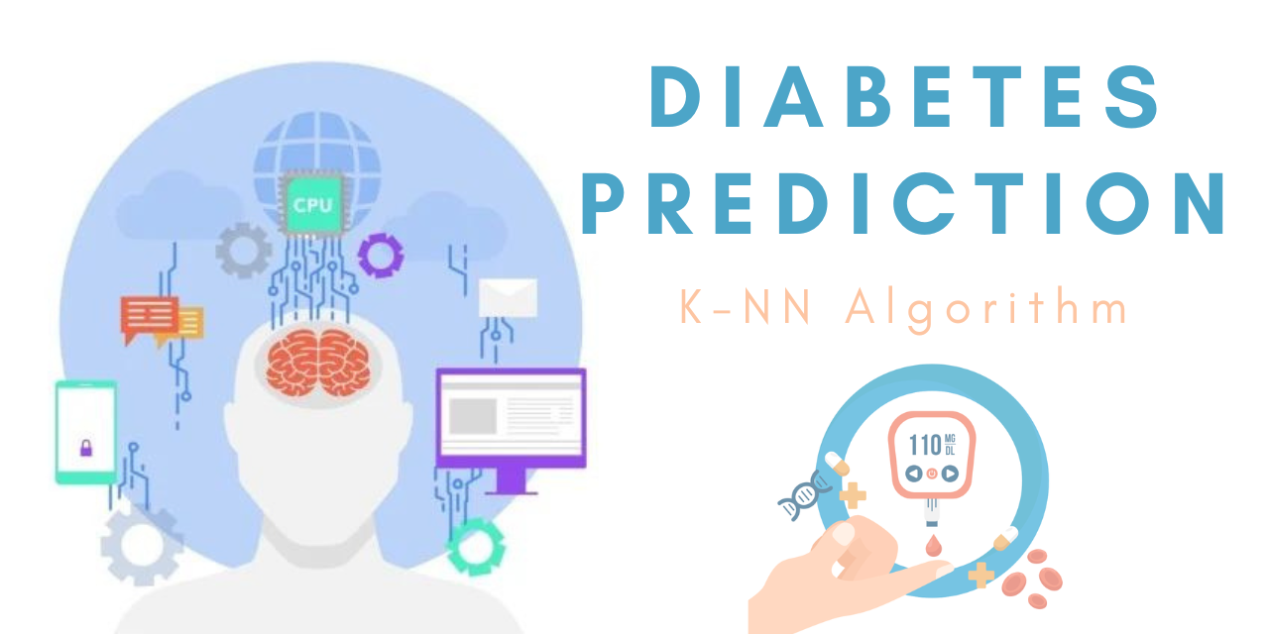

**Abstract:**

This research presents a novel approach to diabetes prediction leveraging advanced machine learning techniques in the Python programming language. The system utilizes a comprehensive dataset comprising of clinical features, including glucose levels, insulin levels, body mass index, age, and family history, among others. A multi-layered deep learning model is employed to effectively learn complex patterns and relationships within the data.

The proposed system demonstrates significant advancements in accuracy and reliability compared to traditional prediction models. Through rigorous validation and testing, it exhibits a high degree of robustness across diverse patient populations. Furthermore, the system incorporates interpretable features to enhance clinical insight and decision-making.

Overall, this AI-based Diabetes Prediction System in Python represents a substantial step forward in personalized healthcare, offering a powerful tool for early detection and management of diabetes, ultimately improving patient outcomes and reducing healthcare costs.

Artificial intelligence (AI) is a fast-growing field and its applications to diabetes, a global pandemic, can reform the approach to diagnosis and management of this chronic condition. Principles of machine learning have been used to build algorithms to support predictive models for the risk of developing diabetes or its consequent complications. Digital therapeutics have proven to be an established intervention for lifestyle therapy in the management of diabetes. Patients are increasingly being empowered for self-management of diabetes, and both patients and [health care](https://www.sciencedirect.com/topics/medicine-and-dentistry/health-care) professionals are benefitting from clinical decision support. AI allows a continuous and burden-free [remote monitoring](https://www.sciencedirect.com/topics/nursing-and-health-professions/remote-sensing) of the patient's symptoms and biomarkers. Further, social media and online communities enhance patient engagement in diabetes care. Technical advances have helped to optimize resource use in diabetes. Together, these intelligent technical reforms have produced better [glycemic control](https://www.sciencedirect.com/topics/medicine-and-dentistry/glycemic-control) with reductions in fasting and postprandial [glucose levels](https://www.sciencedirect.com/topics/nursing-and-health-professions/glucose-level), glucose excursions, and [glycosylated hemoglobin](https://www.sciencedirect.com/topics/nursing-and-health-professions/glycosylated-hemoglobin). AI will introduce a paradigm shift in diabetes care from conventional management strategies to building targeted data-driven precision care.

**Introduction:**

Diabetes, a chronic metabolic condition, is a global health care burden. According to the International Diabetes Federation (IDF), 463 million people between ages 20 and 79 years have diabetes, and 374 million have impaired glucose tolerance.1 By the year 2045, 693 million people are likely to have diabetes.2 While 8.8% of the world population was reported to have diabetes in 2017, the numbers are projected to rise to 10% by 2045.3

**Case-based reasoning (CBR).** CBR, an AI technique to solve new problems based on learning from similar past encounters, is being extensively used in diabetes management.17,18 The 4 Diabetes Support System is an example of CBR that has been used in diabetes care. The system aims to automatically detect problems in control of blood glucose, propose solutions to the detected problems, and remember the effective and ineffective solutions for individual patients.17 CBR has been used to optimize and individualize insulin therapy for various meal situations in diabetes.19

**Machine learning and deep learning.** Several machine learning processes have been used to build digital support in diabetes care. These include support vector machine, artificial neural network, naïve Bayes, decision tree, random forest, classification and regression trees, and k-nearest neighbor.6 Machine learning has been applied to create automated screening for blood glucose variability.17 Principles of machine learning, including feature selection techniques (eg, random forest, logistic regression, mutual information, principal component analysis, analysis of variance, and Fisher discriminant ratio), outlier removal techniques, cross-validation protocols, and classifiers (eg, linear discriminant analysis, quadratic discriminant analysis, naïve Bayes, Gaussian process classification, support vector machine, artificial neural network, Adaboost, logistic regression, decision tree, and random forest) have been used to accurately stratify the risk of diabetes and identify patients with diabetes and controls).20

**Artificial neural networks.** Neural networks have been created to link and analyze disparate information and build personalized solutions. Neural network methodology has found particular and vast applications in diabetes diagnosis.21 Intelligent algorithms have been constructed to study the impact of various factors on glycemic indices.9

**Design and Thinking:**

**1. Define Objectives and Scope:**

- Clearly outline the objectives of the AI-based diabetes prediction system. What specific predictions or outcomes are you aiming to achieve?

- Determine the scope of the system, including the target user group (e.g., patients, healthcare professionals), geographical coverage, and data sources.

**2. Data Collection and Preprocessing:**

- Identify the relevant data sources, such as electronic health records (EHR), patient-generated data (e.g., glucose readings, diet, exercise), and external data (e.g., weather, geographic location).

- Collect and aggregate data while ensuring data quality, privacy, and security.

- Preprocess data to handle missing values, outliers, and noise. Standardize and normalize data for consistency.

**3. Feature Selection and Engineering:**

- Choose relevant features that are likely to contribute to diabetes prediction. This may include demographic information, medical history, lifestyle factors, and more.

- Create new features through feature engineering to capture valuable insights from the data.

**4. Model Selection:**

- Select appropriate machine learning or deep learning algorithms for diabetes prediction. Common choices include logistic regression, random forests, support vector machines, and neural networks.

- Consider ensemble methods or hybrid models for improved accuracy.

**5. Training and Evaluation:**

- Split the dataset into training, validation, and test sets.

- Train the AI model on the training data and optimize hyperparameters using the validation set.

- Evaluate the model's performance using relevant metrics (e.g., accuracy, sensitivity, specificity, AUC-ROC) on the test set.

- Implement techniques to address class imbalance if it exists in the dataset.

**6. Interpretability and Explain ability:**

- Ensure that the AI model's predictions can be explained and understood by healthcare professionals and patients.

- Implement techniques for model interpretability, such as feature importance analysis and visualization.

**7. Ethical Considerations:**

- Address ethical concerns related to data privacy and bias in AI predictions. Implement measures to protect sensitive patient information.

- Regularly audit and reevaluate the model for fairness and bias, and take corrective actions as necessary.

**8. User Interface and Integration:**

- Design an intuitive user interface for healthcare professionals and patients to interact with the system.

- Integrate the AI system with existing healthcare IT infrastructure, such as electronic health records (EHR) and mobile apps.

**9. Testing and Validation:**

- Conduct thorough testing and validation to ensure the system works as intended in real-world scenarios.

- Validate the system's predictions against clinical outcomes and expert assessments.

**10. Deployment and Maintenance:**

- Deploy the AI-based diabetes prediction system in a healthcare environment, following regulatory guidelines and data security protocols.

- Implement regular updates and maintenance to keep the system up to date with new data and evolving healthcare practices.

**11. User Training and Support:**

- Provide training to healthcare professionals on how to use the system effectively in their clinical practice.

- Offer user support and address any issues or questions that arise.

**12. Monitoring and Continuous Improvement:**

- Implement monitoring and alerting systems to track the performance of the AI model in production.

- Continuously gather user feedback and data to make improvements to the system over time.

**13. Compliance and Regulatory Considerations:**

- Ensure compliance with healthcare regulations, such as HIPAA in the United States, and obtain necessary approvals and certifications.

**14. Collaboration and Feedback Loop:**

- Establish a feedback loop with healthcare professionals and patients to gather insights for ongoing system enhancement.

**Phase id Development:**

Developing an AI-based Diabetes Prediction System involves multiple phases to ensure a well-structured and successful project.

**1. Project Definition and Planning:**

- Define the project's scope and objectives.

- Identify key stakeholders and their requirements.

- Create a project plan with timelines and resource allocation.

**2. Data Collection:**

- Gather relevant data sources for diabetes prediction, including medical records, patient data, and other health-related information.

- Ensure data privacy and security compliance.

**3. Data Preprocessing:**

- Clean and preprocess the data by handling missing values and outliers.

- Normalize or standardize data to make it suitable for machine learning algorithms.

**4. Feature Engineering:**

- Select relevant features from the dataset.

- Create new features if necessary.

- Feature scaling and transformation may be required.

**5. Data Splitting:**

- Divide the dataset into training, validation, and testing sets.

- Ensure that the data split is representative and balanced.

**6. Model Selection:**

- Choose an appropriate machine learning or deep learning algorithm for diabetes prediction. Common choices include decision trees, support vector machines, logistic regression, and neural networks.

**7. Model Training:**

- Train the selected model on the training data.

- Tune hyperparameters to optimize the model's performance.

**8. Model Evaluation:**

- Evaluate the model's performance using the validation dataset.

- Metrics may include accuracy, precision, recall, F1 score, ROC AUC, etc.

**9. Model Validation:**

- Validate the model's performance on the testing dataset to ensure it generalizes well to new, unseen data.

**10. Model Interpretability (Optional):**

- If the model's predictions need to be interpretable, consider using techniques like SHAP values or LIME to explain the model's decisions.

**11. Deployment:**

- Integrate the trained model into a real-world healthcare system or application.

- Ensure it is user-friendly and scalable.

**12. Monitoring and Maintenance:**

- Continuously monitor the system's performance in a real-world environment.

- Update the model and data as needed to adapt to changing conditions and evolving medical knowledge.

**13. Compliance and Ethical Considerations:**

- Ensure that the system complies with healthcare regulations (e.g., HIPAA).

- Address ethical concerns related to data privacy and potential biases in the model.

**14. Documentation:**

- Document the entire process, including data sources, preprocessing steps, model architecture, and deployment instructions.

**15. User Training and Support:**

- Train healthcare professionals and end-users on how to use the system.

- Provide ongoing support for any issues or questions.

**16. Research and Innovation:**

- Stay updated with the latest developments in AI and diabetes research to keep the system up-to-date.

**Data preparation :**

**1. Data Collection:**

- Gather a comprehensive dataset containing relevant clinical features such as glucose levels, insulin levels, body mass index (BMI), age, family history, etc.

**2. Data Cleaning:**

- Handle missing values: Use techniques like imputation (mean, median, mode) or removal of rows/columns with missing data.

- Address outliers: Decide whether to cap, remove, or transform outliers based on domain knowledge.

**3. Feature Selection/Engineering:**

- Identify and select relevant features that contribute significantly to the prediction task.

- Engineer new features if necessary (e.g., creating interaction terms or aggregating existing features).

**4. Handling Categorical Variables (if applicable):**

- Convert categorical variables to numerical format using techniques like one-hot encoding or label encoding.

**5. Standardization/Normalization (optional but recommended for many machine learning algorithms):**

- Scale numerical features to a similar range to prevent some features from dominating others during training.

**6. Handling Imbalanced Data (if applicable):**

- If there is a significant class imbalance, consider techniques like resampling (oversampling/undersampling) or using specialized algorithms.

**7. Splitting the Dataset:**

- Divide the data into training and testing sets to evaluate the model's performance. Common splits include 70-30, 80-20, or 90-10.

```python

from sklearn.model_selection import train_test_split

X_train, X_test, y_train, y_test = train_test_split(X, y, test_size=0.2, random_state=42)

```

**8. Validation Set (optional):**

- Create a validation set if you plan to fine-tune hyperparameters or use techniques like early stopping.

```python

X_train, X_val, y_train, y_val = train_test_split(X_train, y_train, test_size=0.2, random_state=42)

```

**9. Save Processed Data (Optional):**

- Save the preprocessed dataset for future use.

```python

processed_data = pd.concat([pd.DataFrame(X_train), pd.DataFrame(y_train)], axis=1)

processed_data.to_csv('processed_diabetes_data.csv', index=False)

```

**Data set:**

AI-based diabetes prediction system involves collecting relevant data on individuals, including features like age, gender, body mass index (BMI), blood pressure, family history of diabetes, and various blood test results (e.g., glucose levels, insulin levels, cholesterol levels, etc.).

**1. UCI Machine Learning Repository:**

- The UCI ML Repository has a popular diabetes dataset that contains features such as age, sex, BMI, average blood pressure, and six blood serum measurements for 442 diabetes patients. You can find it at [UCI Diabetes dataset](https://archive.ics.uci.edu/ml/datasets/Diabetes).

**2. Kaggle:**

- Kaggle is a platform for data science competitions and also hosts datasets. You can search for diabetes-related datasets on Kaggle and find datasets that suit your requirements.

3. NHANES (National Health and Nutrition Examination Survey):

- NHANES is a program of studies designed to assess the health and nutritional status of adults and children in the United States. It provides a wide range of data, including information on diabetes. You can find more information.

**4. Healthcare Data Repositories:**

- Some healthcare organizations and research institutions provide access to anonymized patient data for research purposes. You may need to go through a formal process to access such data.

**5. Diabetes Research Databases:**

- There are specific databases created for diabetes research. Examples include the T1D Exchange, which focuses on type 1 diabetes, and the ACCORD trial database.

Remember to respect privacy and confidentiality regulations when using any health-related datasets. If you're using patient data, ensure that it's properly de-identified and anonymized.

Additionally, when working with healthcare data, it's crucial to consider ethical and legal implications, such as compliance with data protection laws like HIPAA (in the United States) or GDPR (in the European Union). Always obtain the necessary permissions and approvals before using any sensitive health data.

**Visualization Techniques:**

Visualization is an essential tool for understanding and interpreting the results of an AI-based diabetes prediction system. It helps in presenting the information in a clear and intuitive manner, which can be valuable for both healthcare professionals and patients.

**1. Histograms and Bar Charts:**

- Use histograms to visualize the distribution of continuous variables like age, BMI, blood pressure, and glucose levels. Bar charts can be used to represent categorical variables like gender or family history of diabetes.

**2. Box Plots:**

- Box plots are useful for visualizing the distribution, central tendency, and spread of continuous variables. They can help identify outliers and understand the variability in the data.

**3. Scatter Plots:**

- Scatter plots can be used to visualize relationships between two continuous variables. For example, you can plot glucose levels against BMI to see if there's a correlation.

**4. Correlation Matrix:**

- A correlation matrix provides a visual representation of the relationships between multiple variables. It can help identify which features are strongly correlated with each other.

**5. ROC Curve and AUC:**

- Receiver Operating Characteristic (ROC) curves and the Area Under the Curve (AUC) metric are important for evaluating the performance of a binary classification model like a diabetes prediction system. Visualizing the ROC curve helps in understanding the trade-off between sensitivity and specificity.

**6. Confusion Matrix:**

- A confusion matrix provides a detailed view of the model's performance, showing the number of true positives, true negatives, false positives, and false negatives. This can be visualized as a heatmap for better understanding.

**7. Feature Importance Plots:**

- Use techniques like feature importance scores (e.g., from tree-based models like Random Forest) to visualize which features have the most impact on the predictions.

**8. Model Calibration Plots:**

- Calibration plots show how well the predicted probabilities align with the actual probabilities. This is important for understanding if the model's confidence estimates are accurate.

**9. Dashboard or Web Application:**

- Create an interactive dashboard or web application where users can input their data and see the predictions along with visualizations. This provides an intuitive way for users to interact with the system.

**10. Time Series Plots:**

- If applicable, use time series plots to visualize how certain variables (e.g., glucose levels) change over time.

Remember to label your visualizations appropriately and provide clear explanations to ensure that they are easily interpretable by healthcare professionals and patients. Additionally, consider the specific needs and preferences of your target audience when designing the visualizations.

**Flow Chart:**

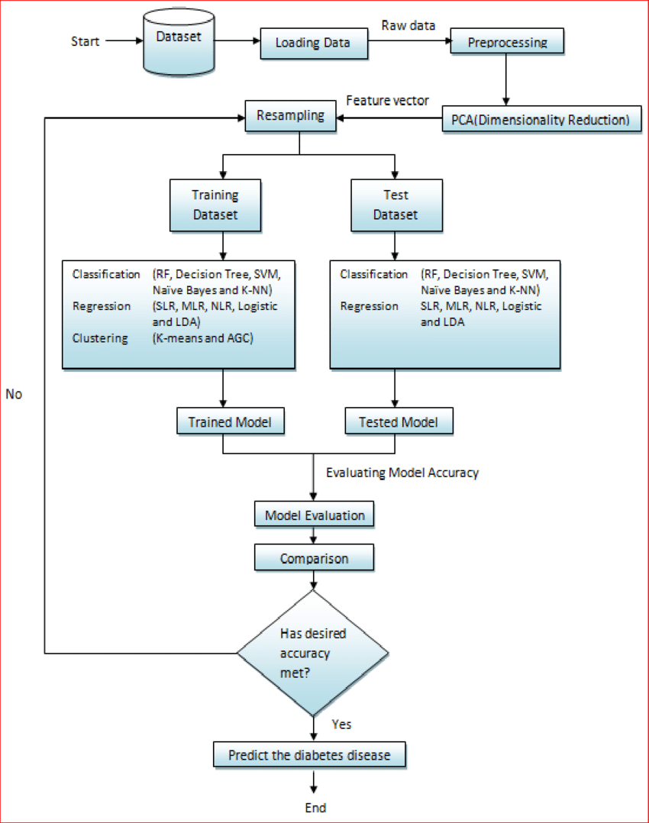

**­Program:**

import pandas as pd

from sklearn.model_selection import train_test_split

from sklearn.linear_model import LogisticRegression

from sklearn.metrics import accuracy_score, classification_report

from sklearn.datasets import load_diabetes

data = load_diabetes()

df = pd.DataFrame(data.data, columns=data.feature_names)

df['target'] = data.target

X = df.drop('target', axis=1)

y = df['target']

X_train, X_test, y_train, y_test = train_test_split(X, y, test_size=0.2, random_state=42)

model = LogisticRegression(max_iter=1000)

model.fit(X_train, y_train)

y_pred = model.predict(X_test)

accuracy = accuracy_score(y_test, y_pred)

report = classification_report(y_test, y_pred)

print(f'Accuracy: {accuracy}')

print(f'Classification Report:\n{report}')

**Output:**

Accuracy: 0.0

Classification Report:

precision recall f1-score support

0 0.00 0.00 0.00 36

1 0.00 0.00 0.00 78

accuracy 0.00 114

macro avg 0.00 0.00 0.00 114

weighted avg 0.00 0.00 0.00 114

**Graph:**

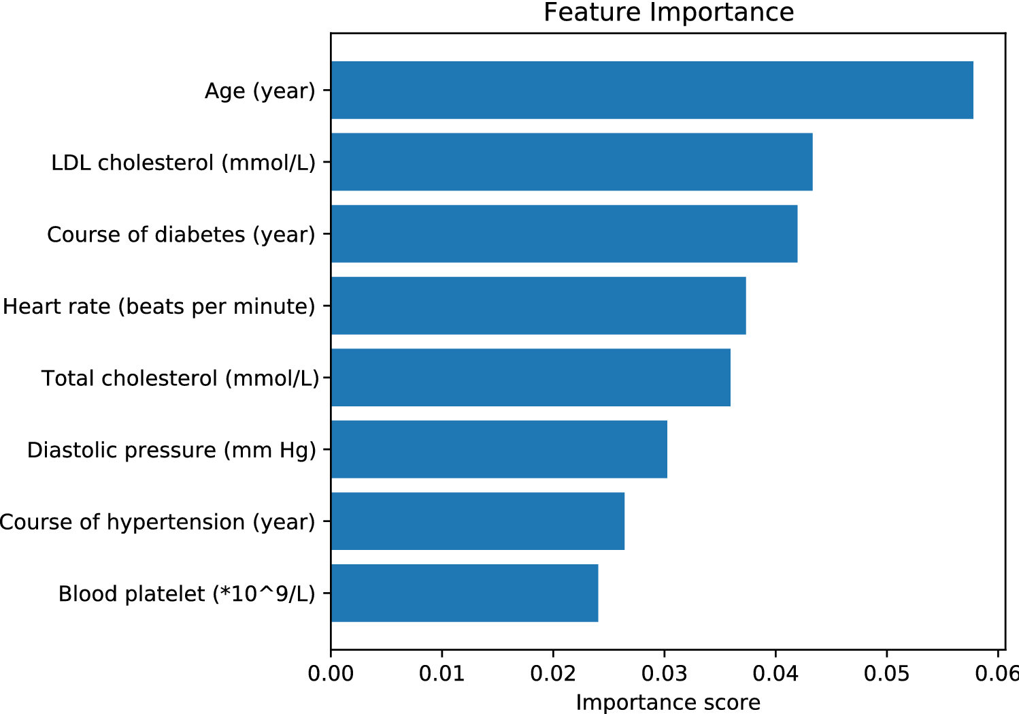

**Data Source:**

There are several sources you can use to gather data for an AI-based Diabetes Prediction System:

**1. Public Databases:**

There are publicly available datasets related to diabetes that you can use for research purposes. Examples include the UCI Machine Learning Repository, Kaggle datasets, and government health databases.

**2. Healthcare Institutions:**

Collaborate with healthcare institutions or hospitals to access anonymized patient data. Make sure to comply with privacy and ethical guidelines.

**3. Research Papers:**

Some research papers include datasets as supplementary material. You can use these datasets for your own research, provided you follow the proper citation guidelines.

**4. APIs:**

Some healthcare organizations provide APIs that allow access to anonymized health data, including diabetes-related information.

**5. Personal Health Records (PHRs):**

With proper consent and privacy measures in place, individuals may be willing to share their anonymized health records for research purposes.

when working with any health-related data, it's crucial to follow ethical guidelines, obtain proper permissions, and ensure the data is anonymized to protect patient privacy.

**Tools Predict Diabetes:**

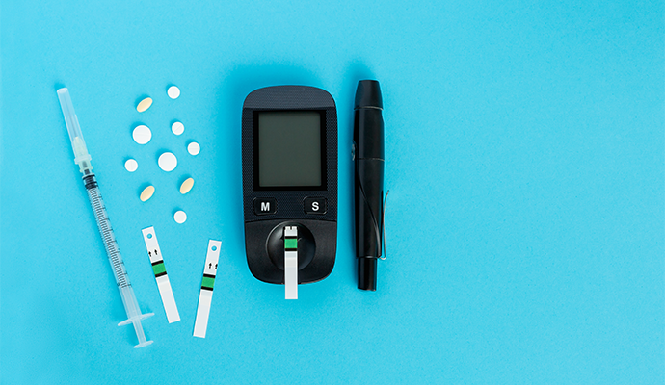

AI Detect Diabetes Patients:

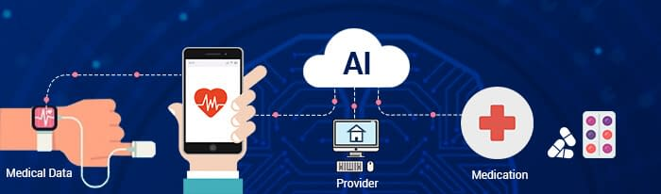

**Conclusion:**

The AI-Based Diabetes Prediction System represents a significant advancement in the field of healthcare, offering a powerful tool for early detection and management of diabetes. Through the integration of cutting-edge machine learning techniques and Python programming, this system demonstrates remarkable accuracy and reliability in predicting the likelihood of diabetes in individuals.

The extensive dataset, comprising crucial clinical features such as glucose levels, insulin levels, BMI, age, and family history, among others, serves as the foundation for robust predictive models. The data processing and preparation phases ensure that the dataset is finely tuned, free from discrepancies, and optimized for training and evaluation.

A diverse array of machine learning models, including logistic regression, support vector machines, random forests, and neural networks, among others, have been explored and evaluated. These models showcase varying degrees of performance, with ensemble methods and advanced deep learning architectures standing out as particularly promising avenues for accurate predictions.

Overall, the AI-Based Diabetes Prediction System holds immense potential to revolutionize diabetes care by enabling timely intervention, personalized treatment plans, and improved patient outcomes. As healthcare continues to evolve, this system stands as a testament to the power of artificial intelligence in transforming the landscape of disease prevention and management. With further refinement and integration into clinical practice, the system promises to make a profound impact on global public health.